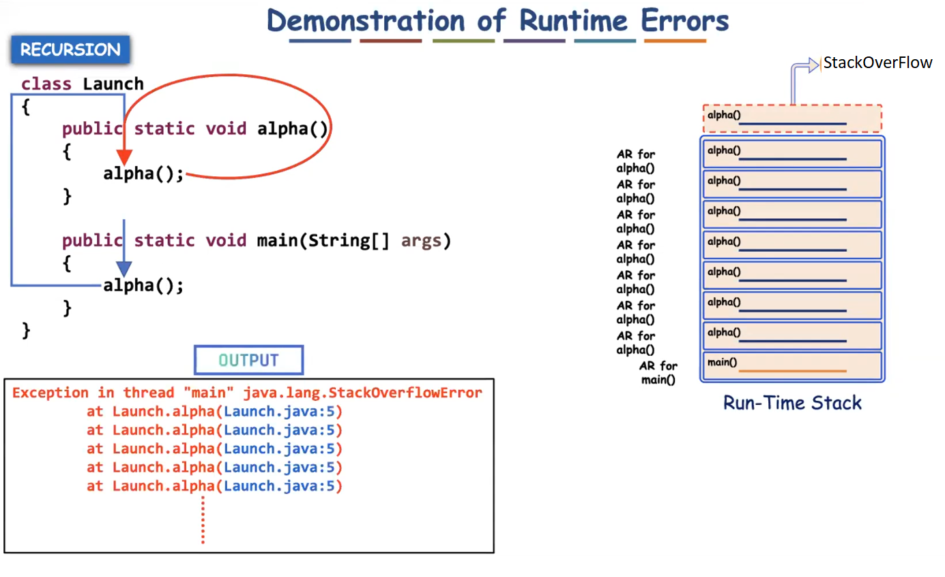

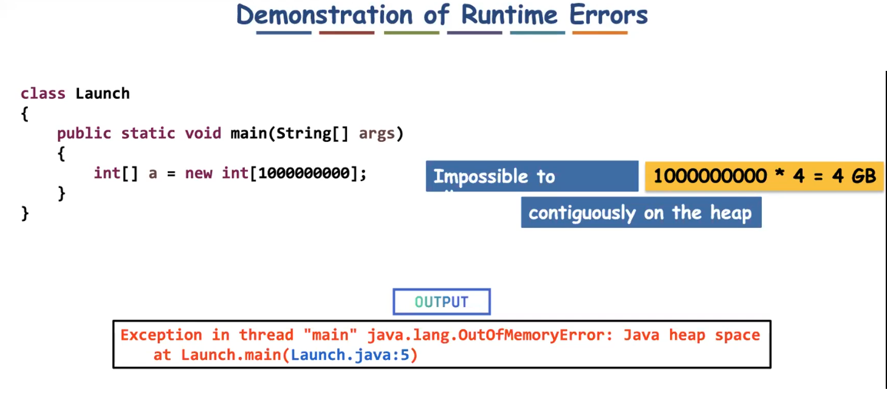

✅ Can if-else Avoid Exception Handling?
No.
if-else cannot replace exception handling.
They are used for different purposes.

✅ What is if-else Used For?
if-else is used for:
- Validating normal conditions
- Handling expected situations
- Making decisions in business logic
Example:
if (balance >= amount) {
withdraw();
} else {
System.out.println("Insufficient balance");
}
This is normal program logic.

✅ What is Exception Handling Used For?
Exception handling is used for:
- Handling unexpected runtime problems
- Handling system-level failures
- Separating error handling from normal logic
- Propagating errors to the caller
Examples:
- File not found
- Database connection failure
- Network timeout
- Null pointer access
- Division by zero

- if-else does not automatically propagate errors.
Exception handling supports propagation through throw and throws.
- Example:
- void withdraw(int amount) throws InsufficientBalanceException {
if (balance < amount) {
throw new InsufficientBalanceException("Not enough balance");
}
}
- Now the caller must handle it.
- This is called exception propagation.

✅ Can if-else Avoid Exception Handling?
No.
if-else cannot replace exception handling.
They are used for different purposes.

✅ What is if-else Used For?
if-else is used for:
- Validating normal conditions
- Handling expected situations
- Making decisions in business logic
Example:
if (balance >= amount) {
withdraw();
} else {
System.out.println("Insufficient balance");
}
This is normal program logic.

✅ What is Exception Handling Used For?
Exception handling is used for:
- Handling unexpected runtime problems
- Handling system-level failures
- Separating error handling from normal logic
- Propagating errors to the caller
Examples:
- File not found
- Database connection failure
- Network timeout
- Null pointer access
- Division by zero

✅ Important Correction About Propagation
You said:
If-else can’t propagate the problem to the caller.
More accurately:
if-else does not automatically propagate errors.
Exception handling supports propagation through throw and throws.
Example:
void withdraw(int amount) throws InsufficientBalanceException {
if (balance < amount) {
throw new InsufficientBalanceException("Not enough balance");
}
}
Now the caller must handle it.
This is called exception propagation.

✅ ATM Example (Refined and Clear)
ATM scenario:
- User enters PIN.
- If PIN is wrong → ATM asks to re-enter.
- After 3 wrong attempts → account gets blocked.
- Blocking information is updated in bank server.
- Even other ATMs cannot access the account.
Now how does this relate?
- Checking PIN format → normal if-else.
- Blocking account after 3 failures → business rule.
- Server update failure, database failure → exception handling.
Wrong PIN itself is not always an exception.
It is usually treated as validation failure.
System failure (like server crash) is an exception.

✅ Very Important Difference
if-else | Exception Handling
Handles expected conditions | Handles unexpected problems
Part of business logic | Separates error logic
No built-in propagation | Supports propagation
Makes code cluttered if overused | Cleaner structured error handling
Does not force handling | Compiler can force handling (checked exceptions)

✅ Why if-else Cannot Replace Exception Handling
- It cannot handle system-level failures.
- It does not separate normal flow from error flow.
- It cannot enforce compile-time checking.
- It does not provide stack trace information.
- It cannot propagate errors automatically.
- It makes code complex if used for every error case.

✅ When to Use What?
Use if-else for:
- Input validation
- Business rules
- Normal conditions
Use exception handling for:
- Technical failures
- Unexpected runtime errors
- Resource failures
- System issues

✅ Final Self-Explanatory Statement
if-else is used to handle expected conditions in program logic.
Exception handling is used to handle unexpected runtime problems and to propagate errors to higher levels of the application.
Therefore, if-else cannot replace exception handling because both serve different purposes.

✅ What is a Custom Defined Exception?
A custom exception is:
An exception class created by the programmer to represent a specific business problem.
Java already gives many exceptions like:
- NullPointerException
- IOException
- ArithmeticException
But in real projects, we create our own.
Example:
- InsufficientBalanceException
- InvalidPinException
- UserNotFoundException

✅ Why Do We Need Custom Exceptions?
Because:
- Built-in exceptions are too generic.
- Business logic needs meaningful error names.
- Code becomes more readable.
- Error handling becomes clean and structured.
Example:
Instead of writing:
throw new Exception("Error");
Better:
throw new InsufficientBalanceException("Not enough balance");
Now the error clearly explains the problem.

✅ Rules to Create Custom Exception
There are 2 types:
1️⃣ Checked Custom Exception
2️⃣ Unchecked Custom Exception

🔹 1️⃣ Rule to Create Checked Custom Exception
If you want it to be checked, extend:
Exception
Syntax:
class MyException extends Exception {
public MyException(String message) {
super(message);
}
}
Important Rules:
- Must extend Exception
- Constructor should call super(message)
- Must handle or declare using throws

Example: Checked Custom Exception
class InsufficientBalanceException extends Exception {
public InsufficientBalanceException(String message) {
super(message);
}
}
Now use it:
class Bank {
void withdraw(int balance, int amount) throws InsufficientBalanceException {
if (balance < amount) {
throw new InsufficientBalanceException("Balance is low");
}
System.out.println("Withdrawal successful");
}
public static void main(String[] args) {
Bank b = new Bank();
try {
b.withdraw(1000, 2000);
}
catch (InsufficientBalanceException e) {
System.out.println(e.getMessage());
}
}
}
Since it is checked → must handle or declare.

Eg: Custom_Checked_Exception

🔹 2️⃣ Rule to Create Unchecked Custom Exception
If you want it to be unchecked, extend:
RuntimeException
Syntax:
class MyException extends RuntimeException {
public MyException(String message) {
super(message);
}
}
No need to declare with throws.

Example: Unchecked Custom Exception
class InvalidPinException extends RuntimeException {
public InvalidPinException(String message) {
super(message);
}
}
Usage:
class ATM {
void checkPin(int pin) {
if (pin != 1234) {
throw new InvalidPinException("Wrong PIN");
}
System.out.println("Access granted");
}
public static void main(String[] args) {
ATM atm = new ATM();
atm.checkPin(1111); // No try-catch required
}
}
Compiler will not force handling.

Eg: Custom_Unchecked_Exception

✅ Complete Rules Summary
Rule 1
Custom exception class must extend either:
- Exception (for checked)
- RuntimeException (for unchecked)

Rule 2
Always provide constructor with message.
public MyException(String message) {
super(message);
}

Rule 3
Use meaningful class names.
Example:
- InvalidAgeException
- PaymentFailedException
- OrderNotFoundException
Avoid:
- MyException
- TestException

Rule 4
Throw using throw keyword.
throw new MyException("Error message");

Rule 5
Checked custom exceptions must be:
- Handled using try-catch
OR
- Declared using throws

Rule 6
Unchecked custom exceptions do not require mandatory handling.

✅ When to Use Checked vs Unchecked?
Use Checked When:
- Caller must handle the situation
- Recovery is possible
- Business rule enforcement needed
Use Unchecked When:
- Programming mistake
- Invalid input
- Logic error
- You don’t want forced handling

✅ Real Project Usage (Spring Boot Example)
In real applications:
Service layer:
if(user == null) {
throw new UserNotFoundException("User not found");
}
Global exception handler catches it and sends proper response.
Very clean architecture.

✅ Interview Ready Explanation
A custom exception is a user-defined exception class created by extending Exception or RuntimeException to represent application-specific errors. Checked custom exceptions must be handled or declared, while unchecked custom exceptions do not require mandatory handling.

